Using SAS with 79 variables and 1400 rows of data this team puts together two multilinear models to predict a home’s sell price in Ames, Iowa.

Kaggle Project

Century 21 Ames: Home Sell Price Prediction Model

Section 401

Jaclyn Coate

Josh Eysenbach

Andrew Leppla

Branum Stephan

# Introduction

## There are many factors that go into buying a house. This investigation will examine [through multilinear regression] the leading factors that can predict housing sale prices for real estate company Century 21 Ames in Ames, Iowa.

## The first analysis will provide a basic prediction model for house sale price based on above grade square footage in neighborhoods where Century 21 Ames currently conducts business [NAmes, Edwards, BrkSide].

## Building on the first model, a second analysis will include up to 79 factors for housing sales across all of Ames, Iowa for a more complete set of predictive models. Variable selection methods will include: forward selection, backward elimination, stepwise selection, and a custom-built model. These models will effectively empower Century 21 Ames to expand from their three active neighborhoods to much more.

# Data Description

## The data in this evaluation contains over 1400 rows and 79 different variables that could contribute to the selling price of a home in Ames, Iowa. The data was collected across 25 different neighborhoods from houses that have been built between 1872 – 2010.

## In our first analysis, we will be using the following variables to predict sale price: *GrLivArea* [living area square footage], *SalesPrice* [sales prices of homes in neighborhoods], and *Neighborhoods* [NAmes, Edwards, BrkSide].

## In our second analysis we will be building a predictive model for sales prices of all the homes in Ames, Iowa. Using the minimal collinear selection of the 79 variables, we will strive to achieve the lowest Kaggle score that we can.

## To find out more about this data and the definitions of all individual variables you can visit the Kaggle competition website [here](https://www.kaggle.com/c/house-prices-advanced-regression-techniques/data) [https://www.kaggle.com/c/house-price-advanced-regression-techniques/data]. To find us on the leaderboards, look for team “Missing Value”!

# Analysis Question 1

## Problem Statement

## Century 21 Ames wants an estimate of how the sale price of a house is related to the square footage of the living area of the home in their three active neighborhoods: NAmes, Edwards, and BrkSide.

## Build and Fit the Model

### Assumptions and Corresponding Plots

#### Linearity

#### Met with the original data set. We see in Figure 5.1.1 the data does reasonably fall along a straight (nonhorizontal) line and nearly passes through the origin. However, we do see evidence of three influential outliers in the data.

#### Outliers Influential point analysis (Studentized Residual, Cook’s D, and Leverage)

#### In Figure 5.1.2 we see outliers in our Studentized Residual Plot.

#### There are three outliers identified with Leverage in Figure 5.1.3 and Cook’s D in Figure 5.1.4. In reviewing the data two of these points are specifically identified as a ‘partial’ and one as an ‘abnormal’ sale. The partial sales are featured houses with overly large extra living areas like garages and basements. We will remove the two partial sale observations from our analysis in order to create a more statistically sound analysis.

#### Linearity – Post Outlier Removal

#### Met with the original data post outlier drop set we see in Figure 5.1.5 the data does reasonably fall along a straight (nonhorizontal) line and nearly passes through the origin.

#### Normality

#### Not met with the data after outlier drops. Judging from the histogram and QQ-plots Figure 5.1.6 and 5.1.7, there is evidence against normality of sale price on fixed values of square footage and neighborhood. In order to move forward we perform a log-linear transformation on the data.

#### Judging from the histogram and QQ-plots Figure 5.1.8 and 5.1.9, once the log-linear transformation has taken place, there is no evidence against normality of sale price on fixed values of square footage and neighborhood.

#### Equal variances

#### Judging from the residuals scatter plot Figure 5.1.10, once the log-linear transformation has taken place, the residual plot resembles a random scatter of points around the 0 line. Therefore, there is no evidence against constant variance of sale price against constant variance of square footage and neighborhood.

#### Independence

#### Homes within the same neighborhoods are often linked in sale price. This is due to the fact that when selling/buying homes real-estate agents references the ‘comps’ (similar homes of living square footage and price) within a neighborhood in order to determine a market fair price for the home. This irrefutably means that homes within a neighborhood are not independent of each other therefore violating the assumption of independence. Therefore, we will move forward with caution in this statistical linear modeling of home prices versus living square footage to compete in this Kaggle competition.

#### Multicollinearity

#### NAmes (Dummy003) and NAmes*GrLivArea (Dummy006) have Tolerances = 0 (VIF>>15) indicating collinearity [Figure 5.1.11]. However, this is because NAmes is the reference level which is by definition 100% correlated with the Intercept, and NAmes*GrLivArea is likewise 100% correlated with the slope of GrLivArea. This is simply an artifact of the software’s dummy coding and there are no issues or concerns with collinearity.

### Comparing Competing Models

#### Adj R2 = 0.5263

#### Internal CV Press = 14.0 (varies somewhat due to random 5 folds)

### Model

$\hat{μ}\left\{log(SalePrice) \right| GrLivArea, Neighborhood\}= β_{0}+ {β_{1}GrLivArea+ β}_{2}BrkSide+ β_{3}Edwards+ β_{4}GrLivArea*BrkSide+ β_{5}GrLivArea*Edwards$

### 

## 

## Parameters

### Estimates

$\hat{μ}\left(\log\left(SalePrice\right)\right)= 11.44+.000324*GrLivArea - .6517*BrkSide -.4333* Edwards+ .000414* GrLivArea*BrkSide+ .000222* GrLivArea*Edwards$

### Interpretation and Confidence Intervals

#### β0: The intercept in this model [e^11.44 =] $93,000 provides an estimate of the median sale price in the NAmes neighborhood (reference neighborhood) with a GrLivArea of zero square feet. This is an extrapolation and does not have a clear, practical meaning. It could possibly be an indication of the median lot values in NAmes with no house built.

##### 95% confidence interval = (e11.36, e11.525) = ($86,000 , $101,000)

#### β1: Each 100 square foot increase in GrLivArea of houses in the NAmes neighborhood is associated with a multiplicative increase in median sale price of [e^(.000324*100) -1 = e^(.0324) -1 = 1.033 -1 = 0.033*100% =] 3.3%.

##### 95% confidence interval = (e.0264-1, e.0384-1) = (.027, .039) = (2.7%, 3.9%)

#### β2: This is an adjustment of the intercept for the BrkSide neighborhood with respect to the NAmes neighborhood. For GrLivArea of zero square feet, the BrkSide neighborhood has an estimated median sale price [e^(11.44-0.65) = e^10.79 =] $49,000 dollars.

##### 95% confidence interval = (e11.44-0.83, e11.44-0.47) = (e10.61, e10.97) = ($41,000 , $58,000)

#### β3: This is an adjustment of the intercept for the Edwards neighborhood with respect to the NAmes neighborhood. For GrLivArea of zero square feet, the Edwards neighborhood has an estimated median sale price [e^(11.44-0.43) = e^11.01 =] $60,000 dollars.

##### 95% confidence interval = (e11.44-0.60, e11.44-0.27) = (e10.85, e11.17) = ($51,000 , $71,000)

#### β4: Each 100 square foot increase in GrLivArea of houses in the BrkSide neighborhood is associated with a multiplicative increase in median sale price of [e^(.0324+.0414) -1 = e^(.0738) -1 = 1.077 -1 = 0.077*100% =] 7.7%.

##### 95% conf. int. = (e.0324+.0274, e.0324+.0555) = (e.060, e.088) = (0.062, 0.092) = (6.2%, 9.2%)

#### β4: Each 100 square foot increase in GrLivArea of houses in the Edwards neighborhood is associated with a multiplicative increase in median sale price of [e^(.0324+.0222) -1 = e^(.0546) -1 = 1.056 -1 = 0.056*100% =] 5.6%.

##### 95% conf. int. = (e.0324+.0100, e.0324+.0344) = (e.0424, e.0668) = (0.043, 0.069) = (4.3%, 6.9%)

## Conclusion

Given that the model looks to fit (see assumptions covered in section 3.2.1), we now move to interpret the parameter estimates found in section 3.3.1. All GrLivArea, BrkSide, and Edwards were found to be significant when neighborhood NAmes was the reference.

Based on median price per square foot, NAmes generally has more expensive smaller homes but more affordable larger homes compared to BrkSide and Edwards. Median sale prices in NAmes increase by 3.3% per 100 square feet from a baseline of $93,000. BrkSide has more affordable smaller homes but more expensive larger homes. Median sale prices in BrkSide increase by 7.7% per 100 square feet from a baseline of $49,000. Edwards is in between these trends for NAmes and BrkSide. Median sale prices in Edwards increase by 5.6% per 100 square feet from a baseline of $60,000.

It is estimated that the GrLivArea (square footage) explains about 53% of the variation in sale price for house among the NAmes, BrkSide, and Edwards neighborhoods based on the adjusted R-square value.

As suggestive as the findings may be, inferences that go beyond these data are unwise. The data were summarized from available house sales and cannot be representative of any wider population. As usual, no causal interpretation can be made from these observational data.

# Analysis Question 2

## Problem Statement

## What is the best model for predicting the sale prices of homes in Ames, Iowa based on the variables provided? Specifically, what models are generated by using Forward, Backward, and Stepwise selection methods on the provided training data set and what model produces the highest Kaggle score?

## Build and Fit the Model

### Model Selection

We used an internal cross-validation with 5 random folds, because of this, the model selection varies slightly at each run time due to random folds. The random number seed will ensure consistent results each time.

#### Forward

A table description of the model is below, for a more detailed description of the model,

See appendix, Figure 5.2.3.

#### Stepwise

A table description of the model is below, for a more detailed description of the model,

See appendix, Figure 5.2.4.

#### Backward

A table description of the model is below, for a more detailed description of the model,

See appendix, Figure 5.2.5.

#### Custom

For the custom model, we actually opted to use the forward selection method because we had already done much preprocessing and “custom” modeling prior to all selection methods. Because the forward selection was our most accurate model, we feel that this is the presentable deliverable.

### Assumptions and Corresponding Plots

#### Linearity

#### Although some initial curvature between Sale Price and the explanatory variables (see scatter plots in Figure 5.2.1), a log-linear transformation created a much stronger linear correlation between Log(Sale Price) and the explanatory variables. By performing the log transform on the Sale Price, we were able to add additional robustness against skewed data. Additionally, the number of bathrooms and overall quality also benefit from a log transformation due to the curvature in the original data. Lastly, we eliminated some features in which the values were heavily inflated with zero values. For example, homes lacking a second floor would have square footage equal to zero, which can more easily be explained by total square footage and number of stories.

#### Outliers Influential point analysis (Studentized Residual, Cook’s D, and Leverage)

#### We removed square footage (GrLivArea) values greater than 4600, as these were considered outlier values. We made sure to remove features which have overly zero values due to the ability to better explain their descriptions through other features. Based on the Cook’s D plot and Studentized Residual plot, we removed two outliers with a high Cook’s D.

#### Normality

#### Even after log transformation and accounting for all variables, the residuals still remained left-skewed as can be seen in Figure 5.2.2. In order to improve the normality of the residuals of the model, we could possibly add or remove some features, however, the model error degrees of freedom over 1000 is enough to invoke the Central Limit Theorem.

#### Equal variances

According to the residual plots of the model, there appears to be a very uniform variance versus predicted values. (Figure 5.2.2)

#### Independence

#### Homes within the same neighborhoods are often linked in sale price. This is due to the fact that when selling/buying homes real-estate agents references the ‘comps’ (similar homes of living square footage and price) within a neighborhood in order to determine a market fair price for the home. This irrefutably means that homes within a neighborhood are not independent of each other therefore violating the assumption of independence.

#### Outliers: Influential point analysis (Cook’s D and Leverage)

For more information on this, please reference section 4.2.2.2.

#### Multicollinearity.

We used a matrix scatter plot and correlation tables to identify and eliminate collinear factors from the model in addition to checking VIF/tolerance to reduce ‘overfitting’ of the model.

### Comparing Competing Models

In our Kaggle submissions, we noticed that the Backward selection received the highest score, thus we decided to proceed with Backward selection as our preferred, ‘custom’ model.

We had already cleaned and pre-selected our features prior to running the backward selection, so we felt that no additional processing was needed. We performed various trial and error iterations; however, we were still most successful with the backwards elimination model.

*Refer to section 4.2.1 for an explanation on the random nature of the scoring.*

|  |  |  |  |
| --- | --- | --- | --- |
| **Predictive Models** | **Adjusted R2** | **CV PRESS** | **Kaggle Score** |
| Forward | .92 | 21 | .127 |
| Backward | .92 | 21 | .134 |
| Stepwise | .93 | 20 | .131 |
| CUSTOM | .92 | 21 | .127 |

## Parameters

### Estimates

All parameter estimates are listed in the appendix in figures 5.2.3 – 5.2.4.

### Interpretation

Due to the large number of both categorical and numerical features, interpretation is not necessarily practical.

### Confidence Intervals

All confidence intervals are listed in the appendix in figures 5.2.3 – 5.2.4.

## Conclusion

### A short summary of the analysis

Utilizing 74 different features, we were able to achieve an r-squared value of 0.91-0.92 across forward, backward, and stepwise selection methods. In minimizing collinearity between all the features chosen, we were able to score within the notable 40th percentile among all Kaggle submissions. The model itself was very refined after much initial exploratory analysis prior to performing the selection method which we believe to have minimized potential for overfitting. Using this approach, we decided to utilize our best performing selection model (backward) as our custom model because we had already customized the model for each prior to running the select method.

Because of the large effect of high-level categorical data on cv-press, we tried running a log transformation on the Sale Price. After log transformation, we appeared to have a much better distribution of residuals and higher r-square value. The influence of the high collinearity variables became more evident when our r-squared shifted from near perfect on training data to much lower on the Kaggle test data. Even though less accurate models tended to give higher Kaggle scores, we believe that we have a very well-designed model that is more practical than merely using all features. We feel confident that the model can be used to estimate homes up to 4,600 square feet and $755,000 Sale Price listing.

# Appendix

## Analysis 1

### 

## Analysis 2

### 

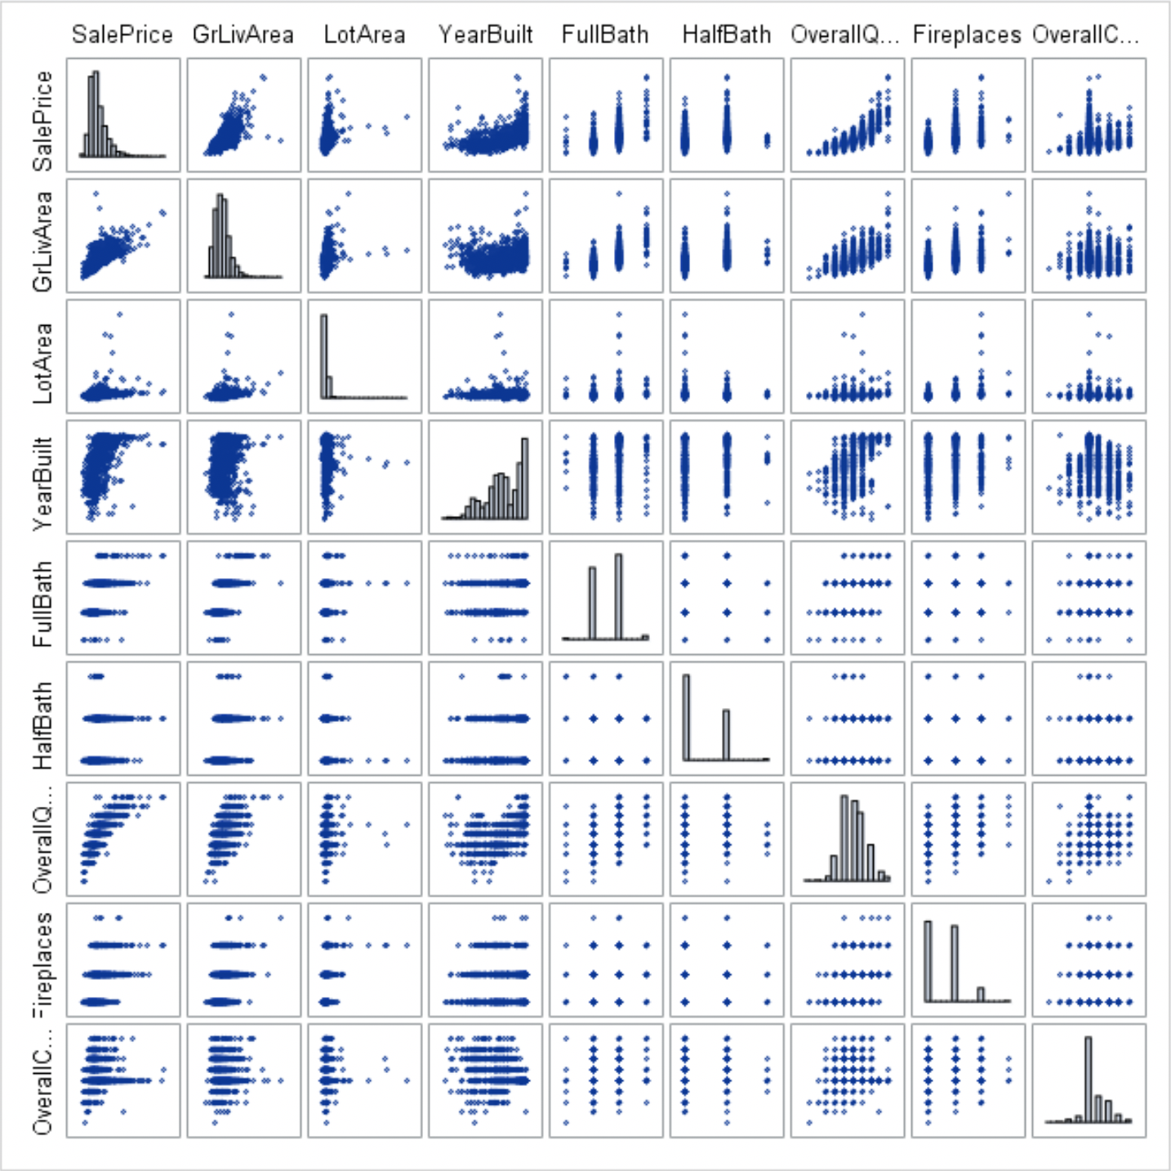

Non-transformed Sale Price

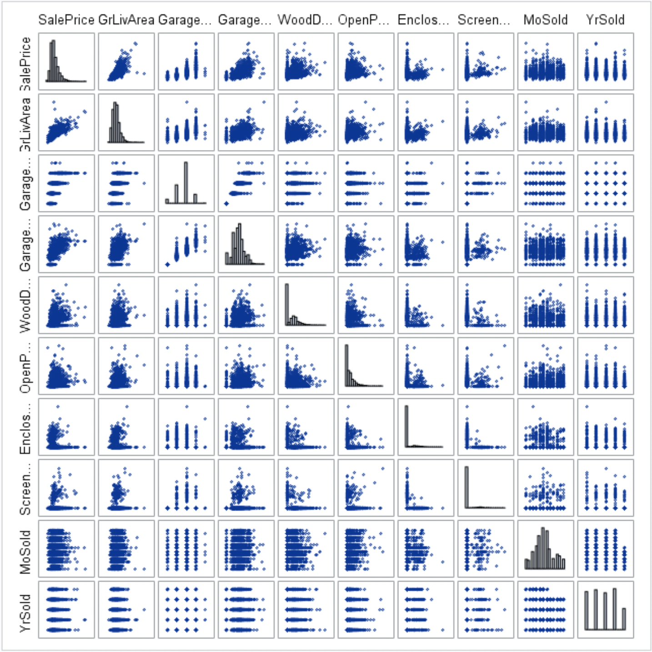

Non-transformed Sale Price

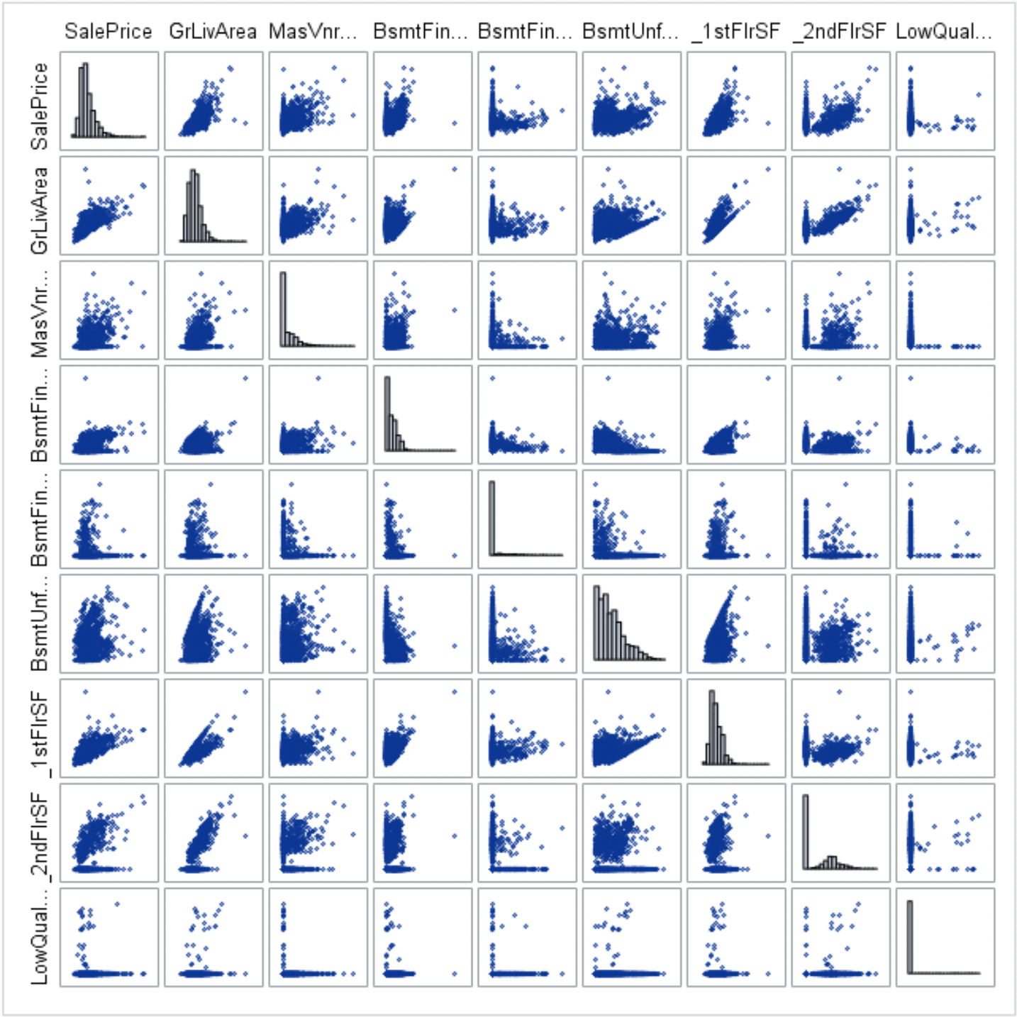

Non-transformed Sale Price

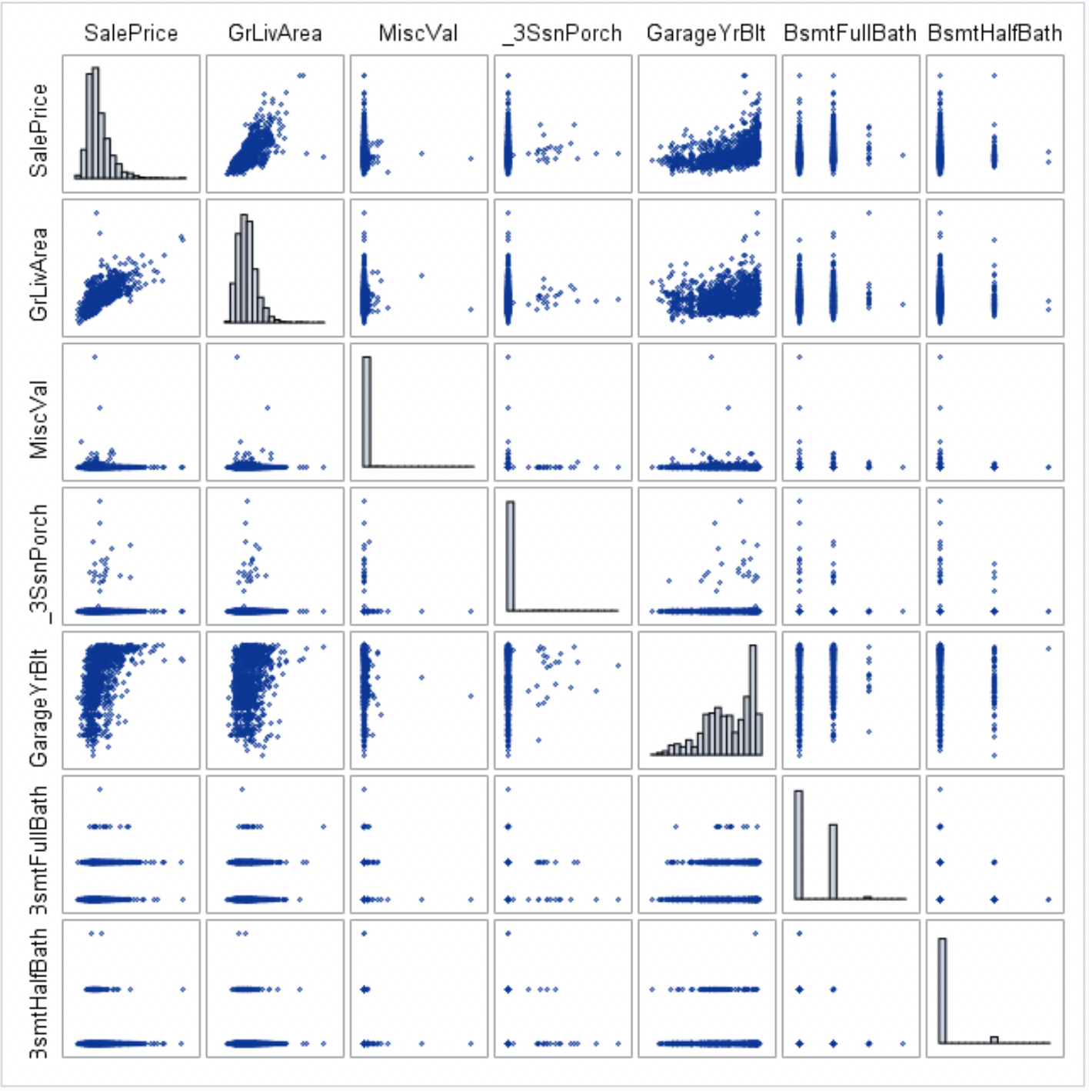

Non-transformed Sale Price

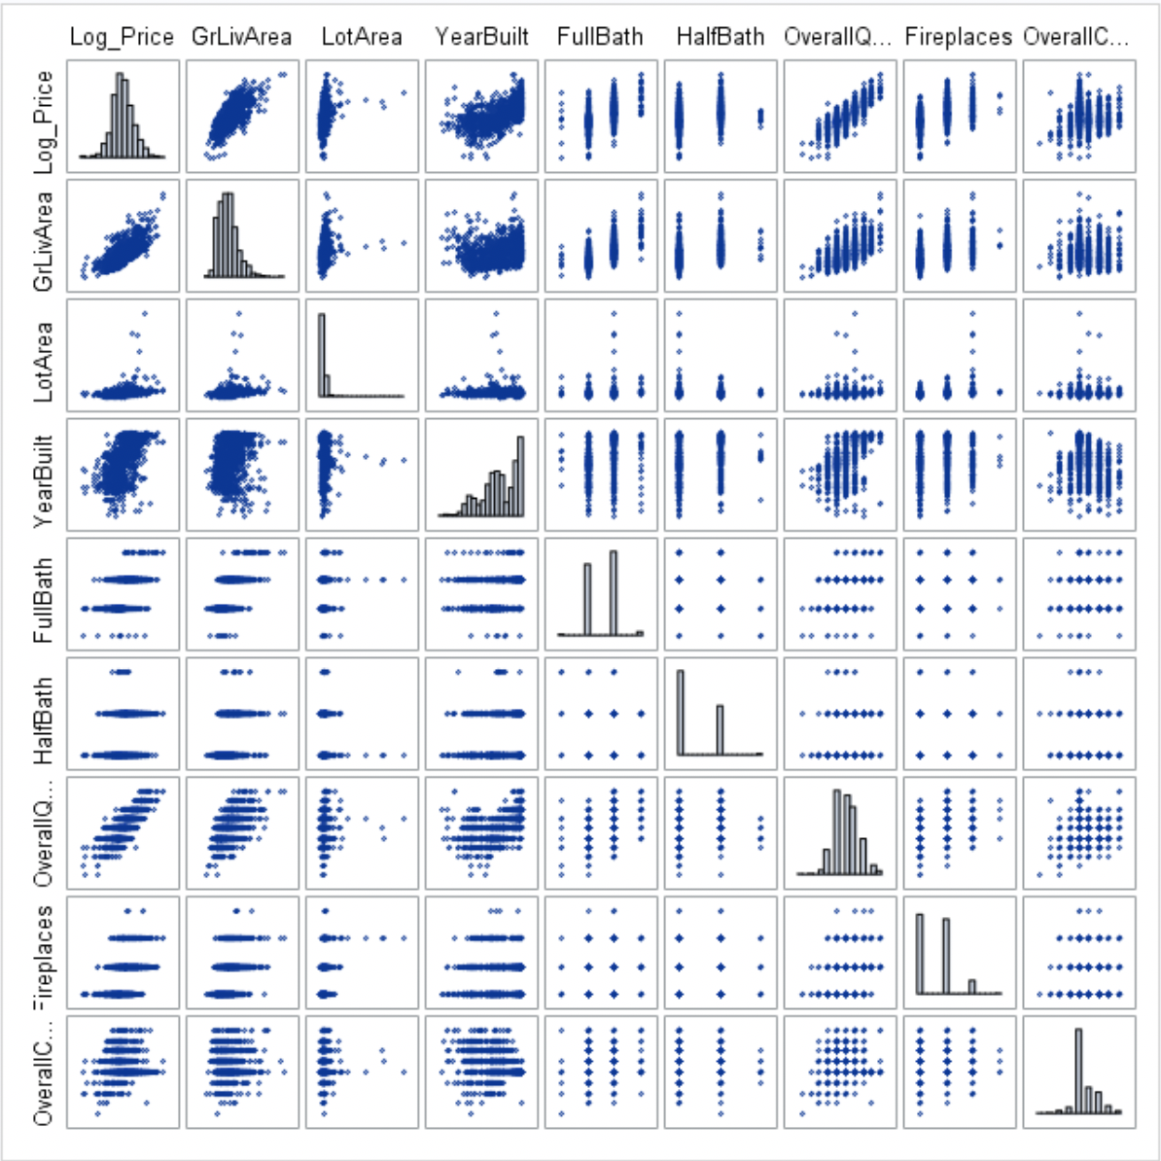

log-transformed Sale Price

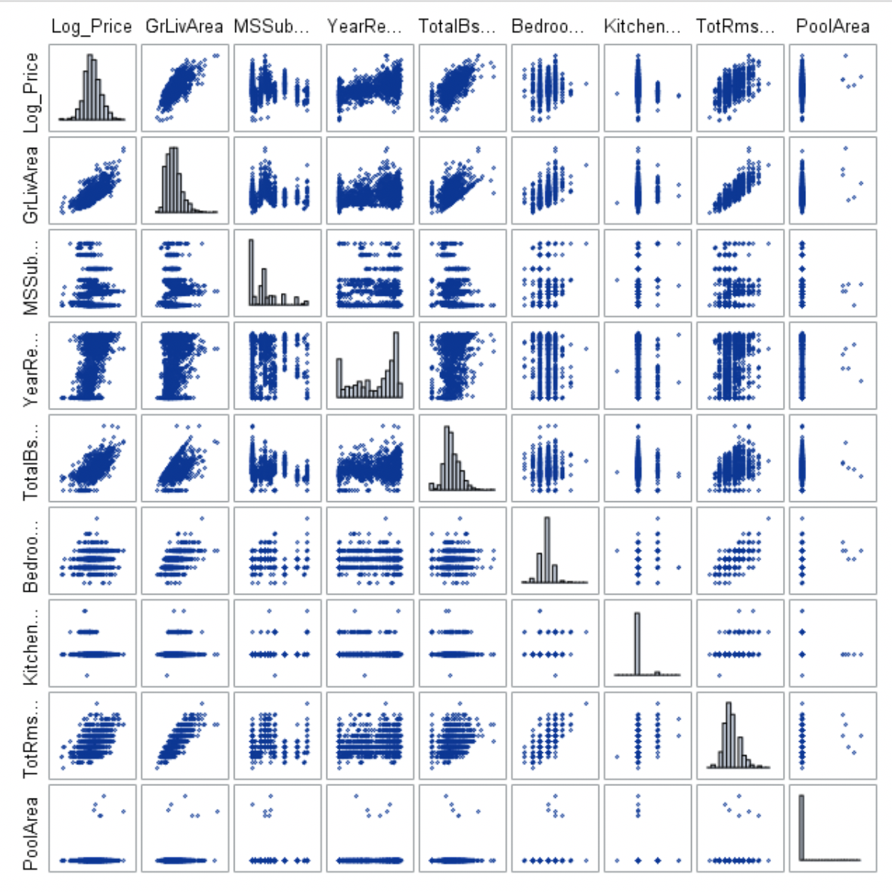

log-transformed Sale Price

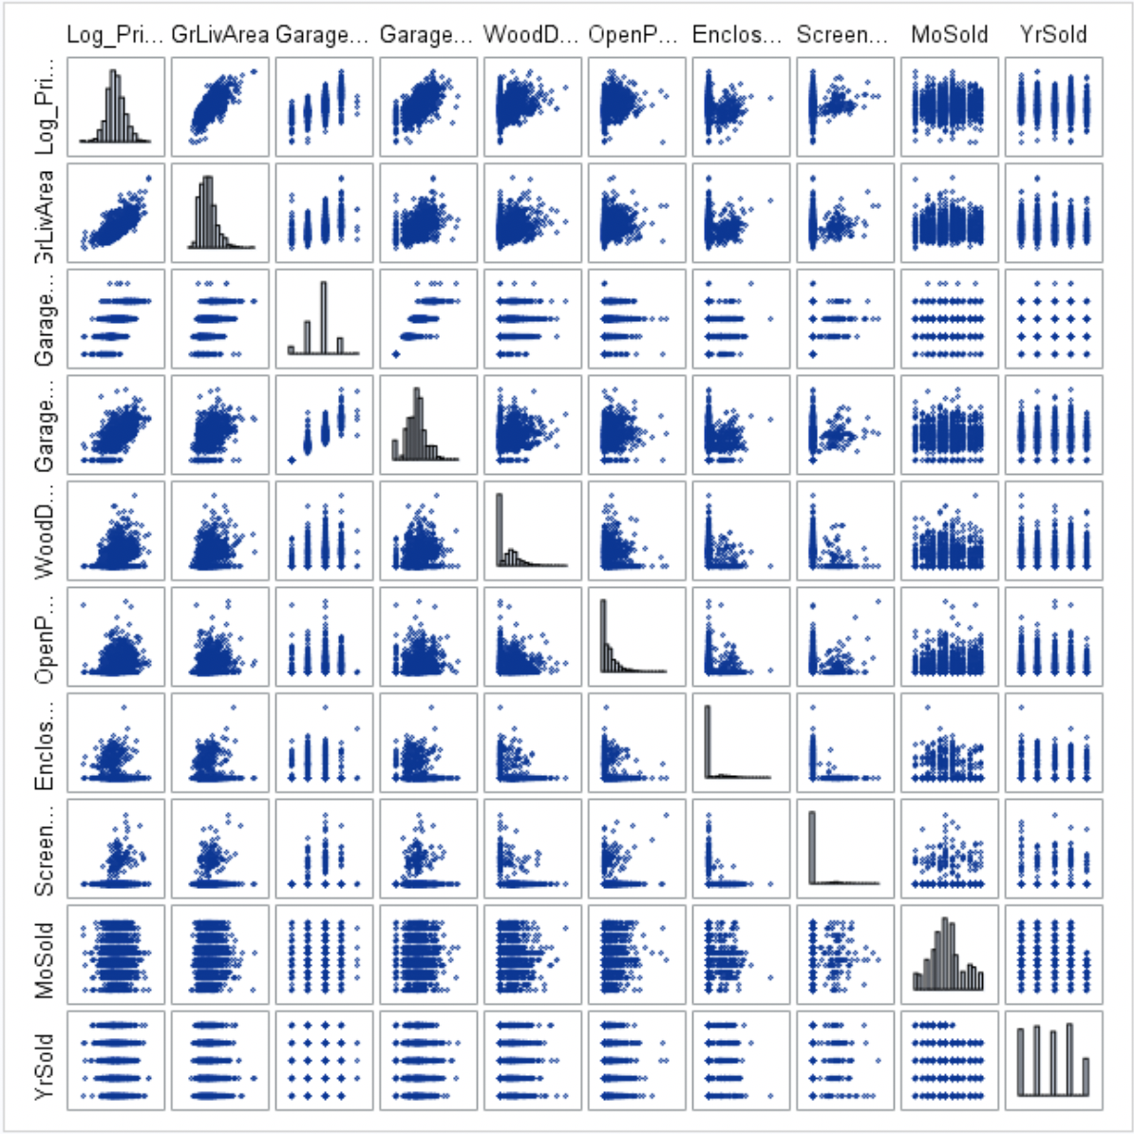

log-transformed Sale Price

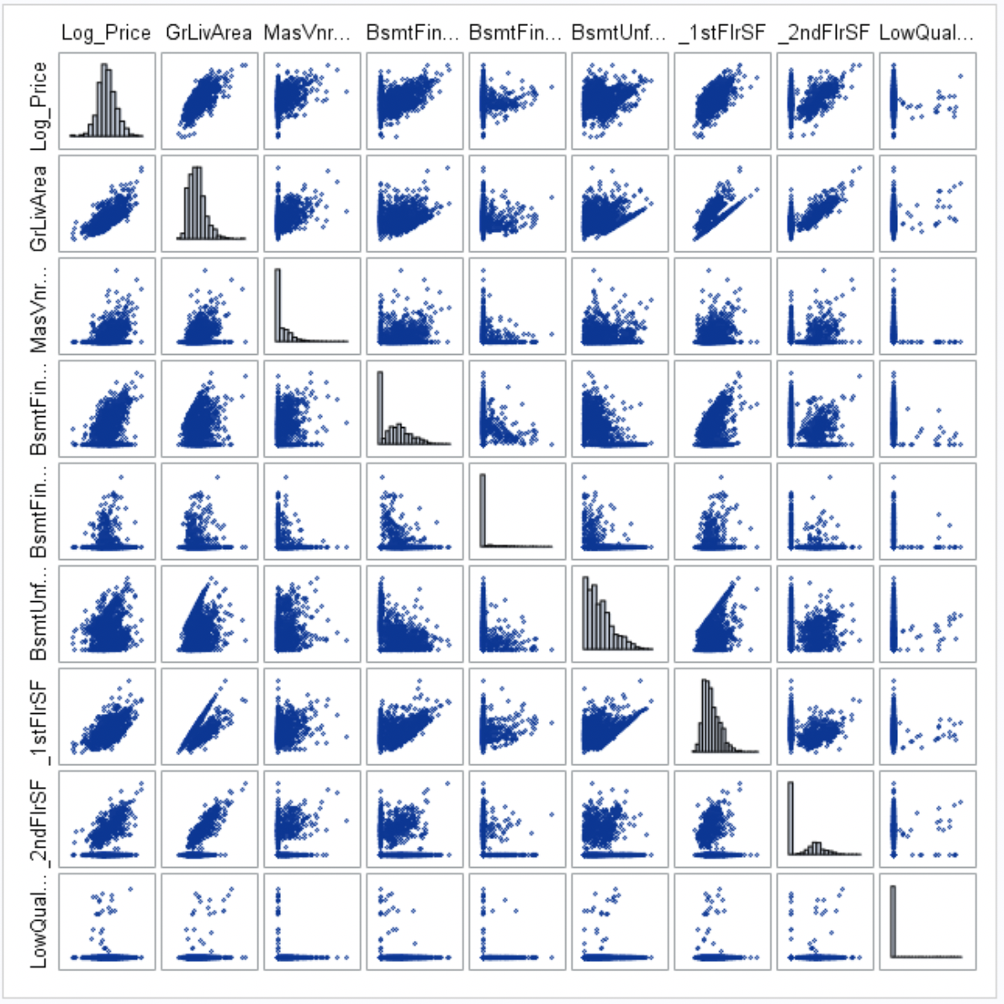

log-transformed Sale Price

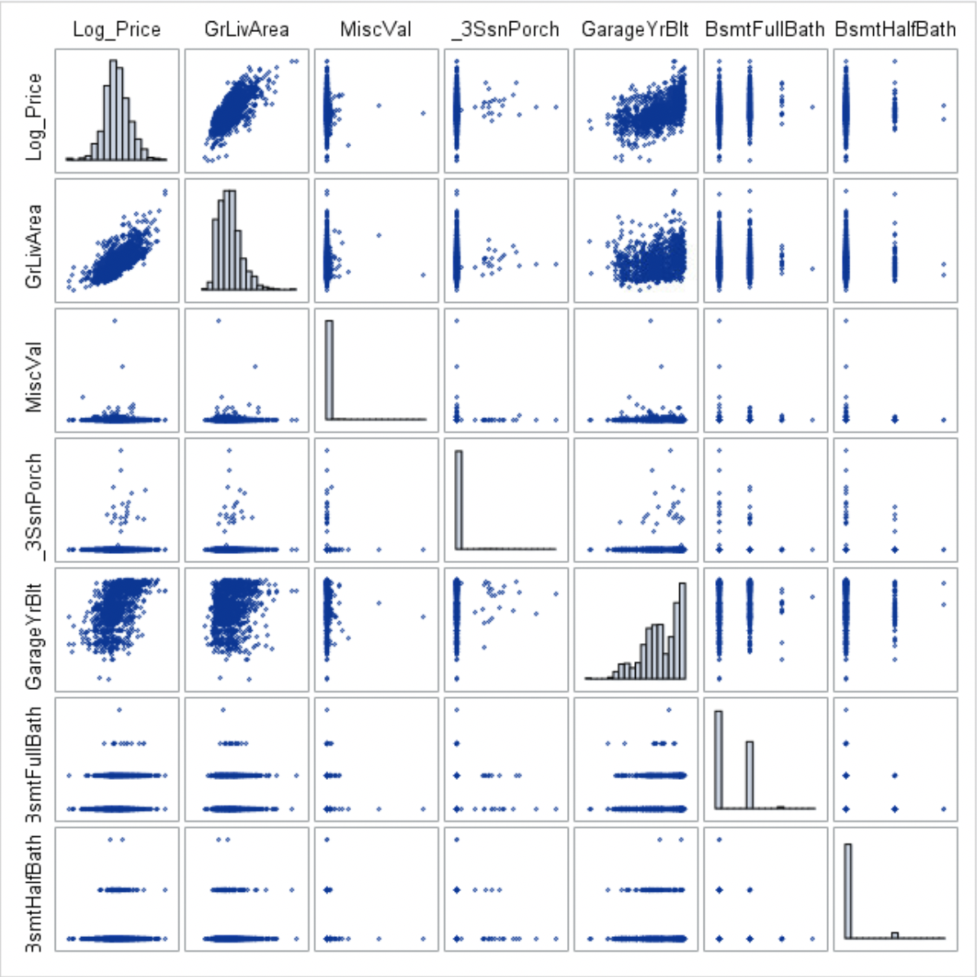

log-transformed Sale Price

### 

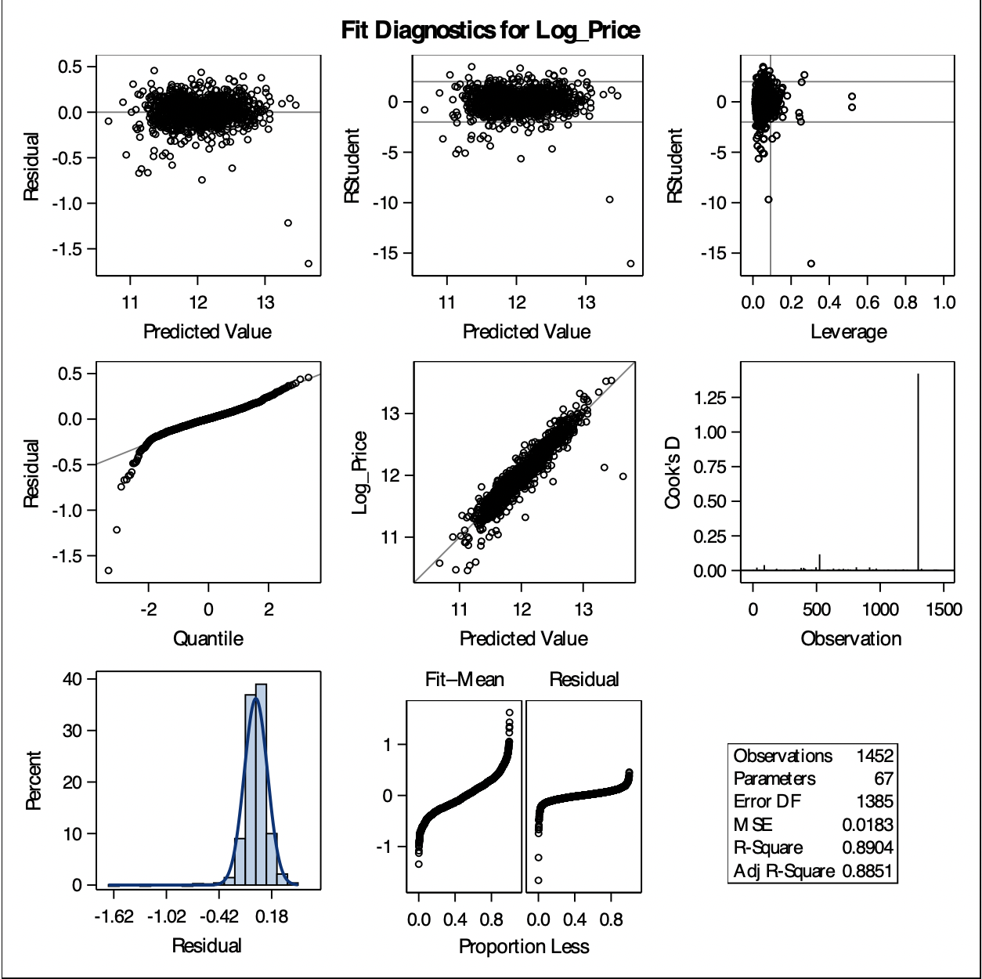

Fit Diagnostics for Log(Sale Price) – Pre Outlier removal

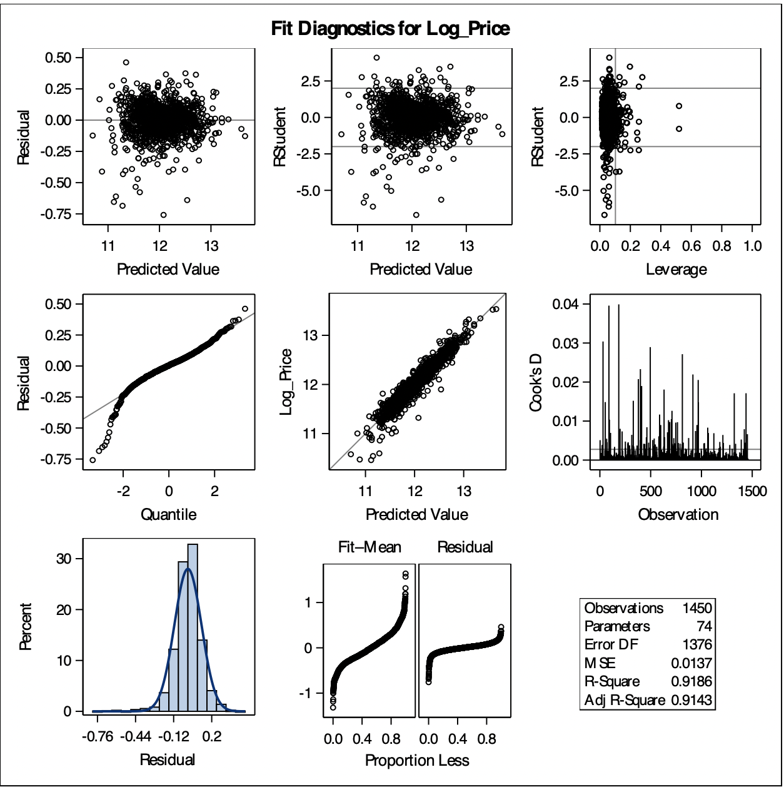

Fit Diagnostics for Log(Sale Price) – Post Outlier removal

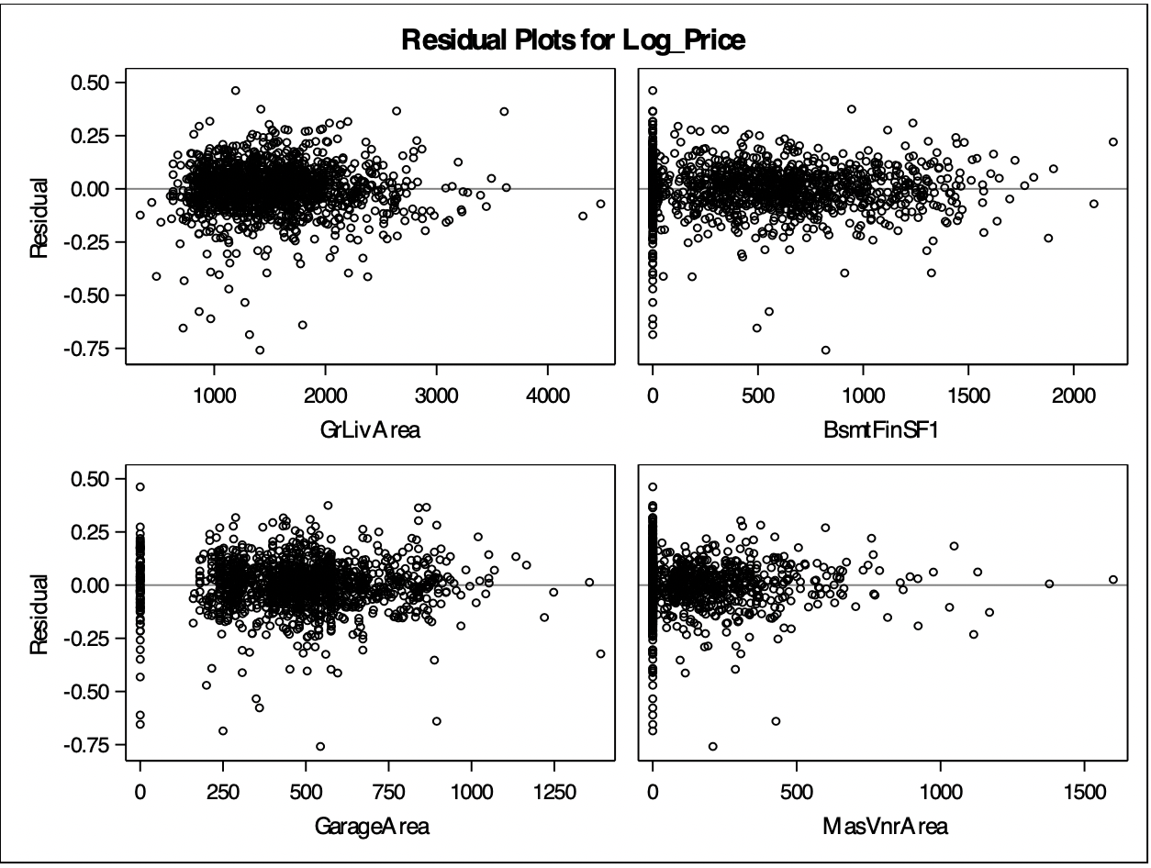

Residual Scatter Plot for Log Price

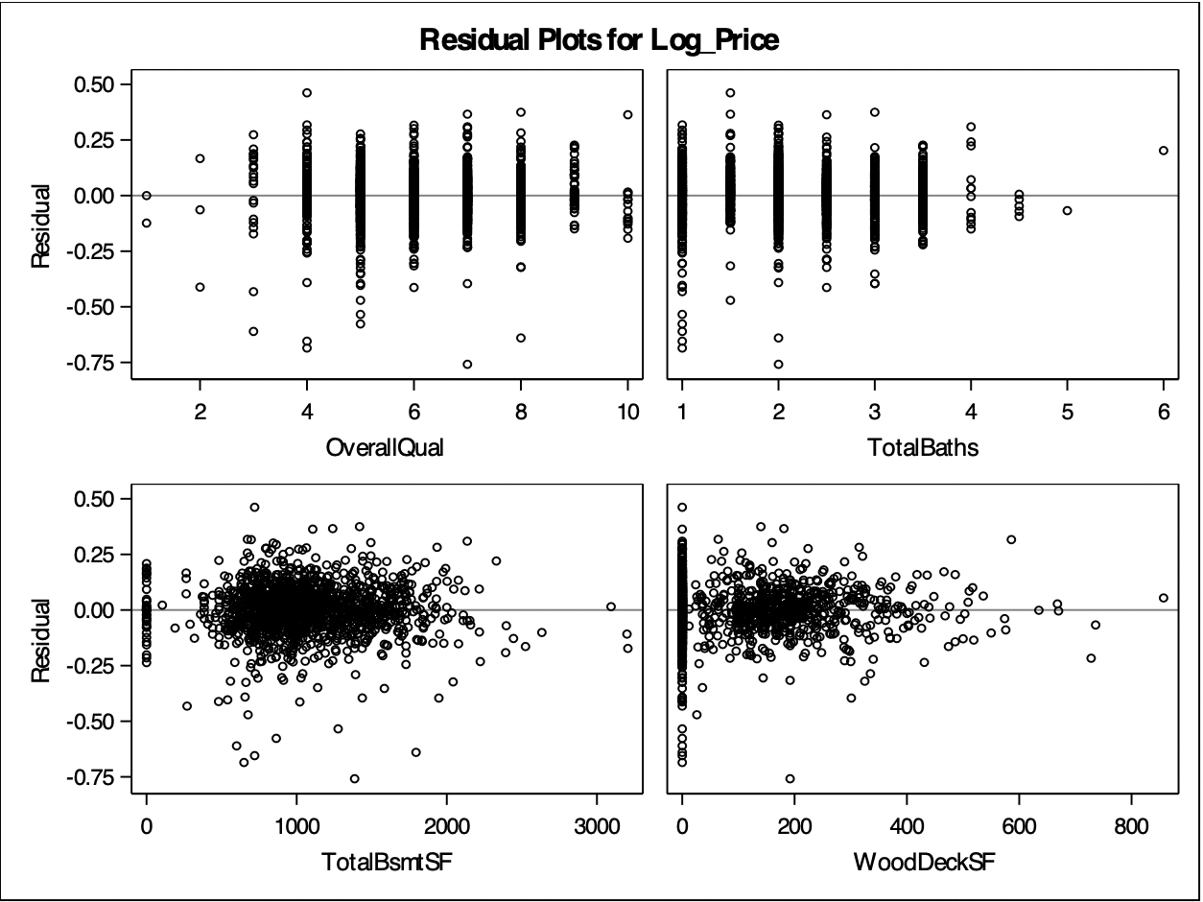

Residual Scatter Plot for Log Price

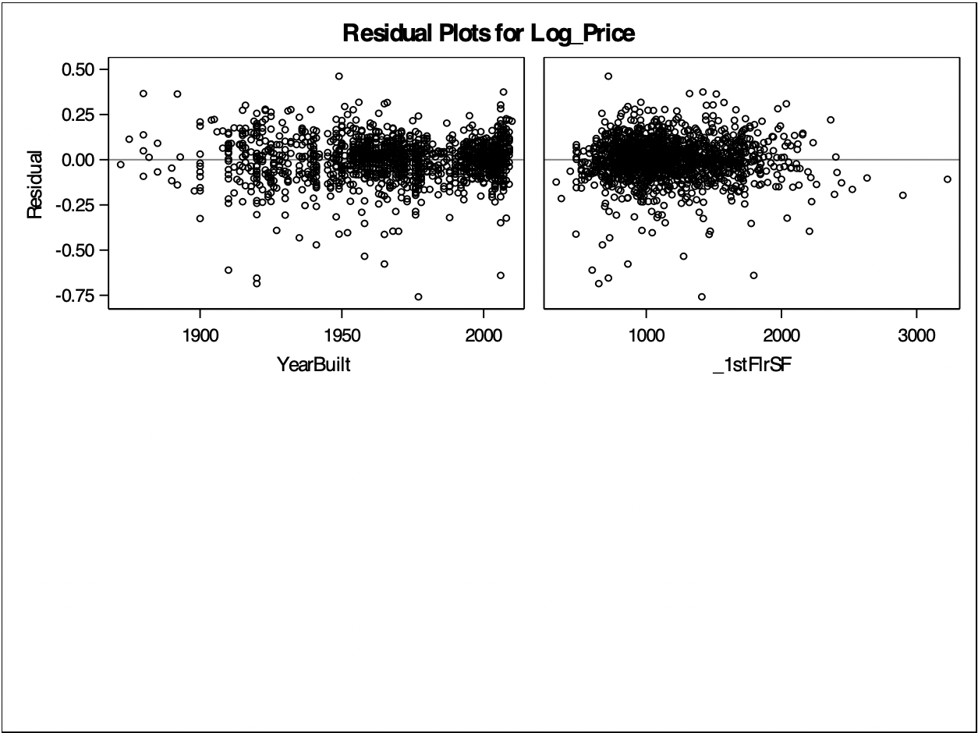

Residual Scatter Plot for Log Price

### 

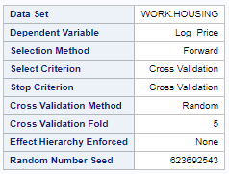

Forward selection – Random Seed Number

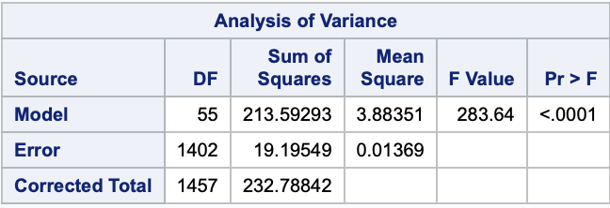

Forward selection – ANOVA Analysis

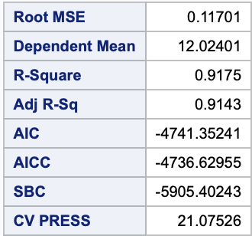

Forward selection – Model Statistics

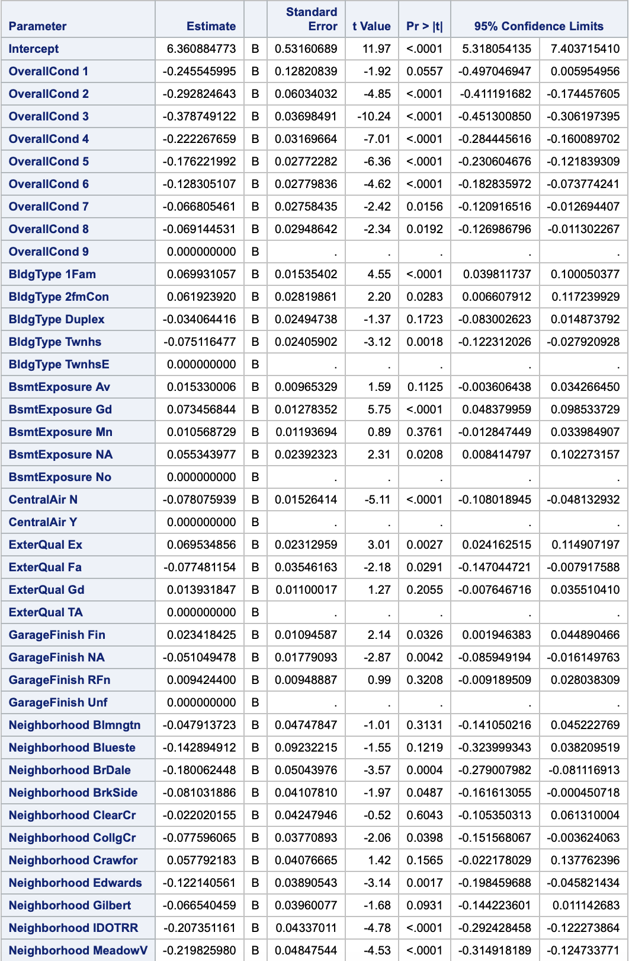

Forward selection – Model Estimates

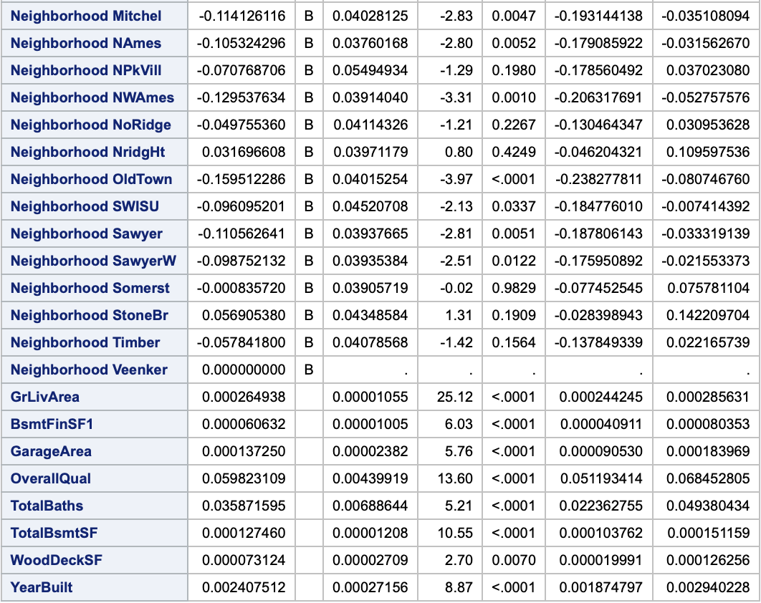

Forward selection – Model Estimates

### 

### 

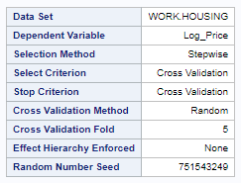

Stepwise selection – Random Seed Number

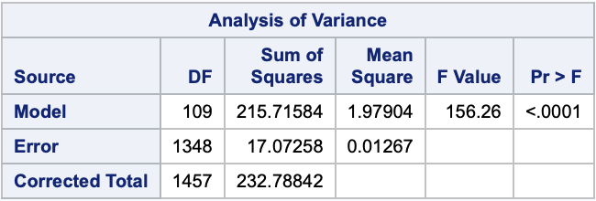

Stepwise selection - ANOVA

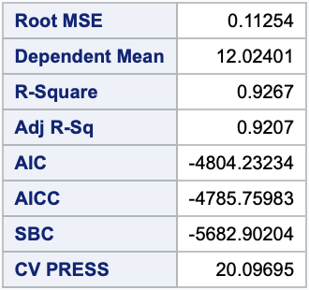

Stepwise selection – Model Statistics

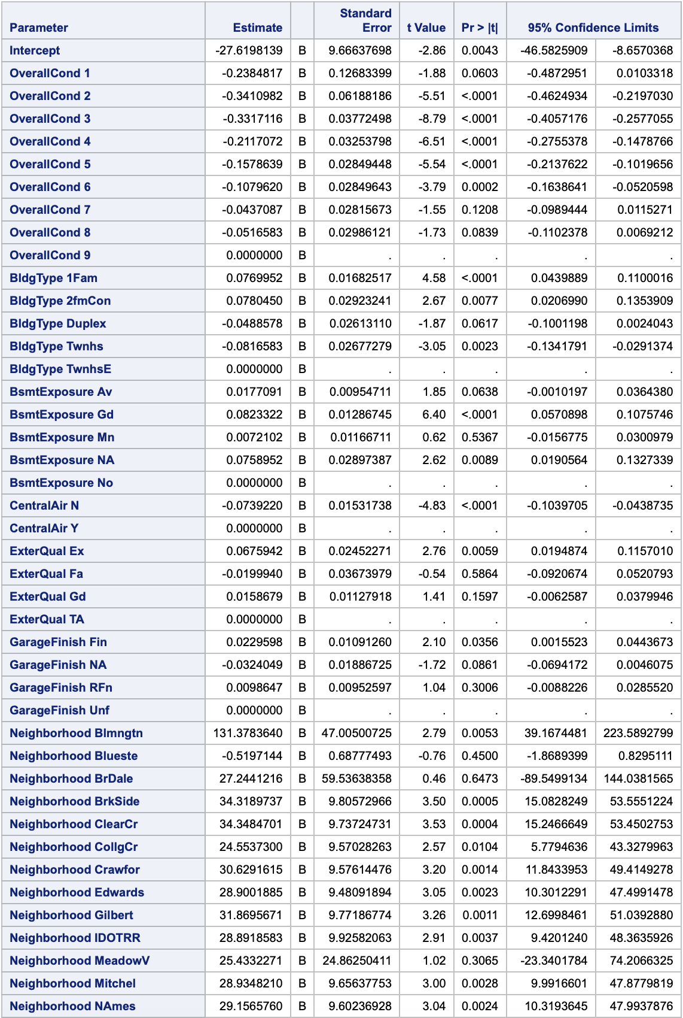

Stepwise selection – Model Estimates

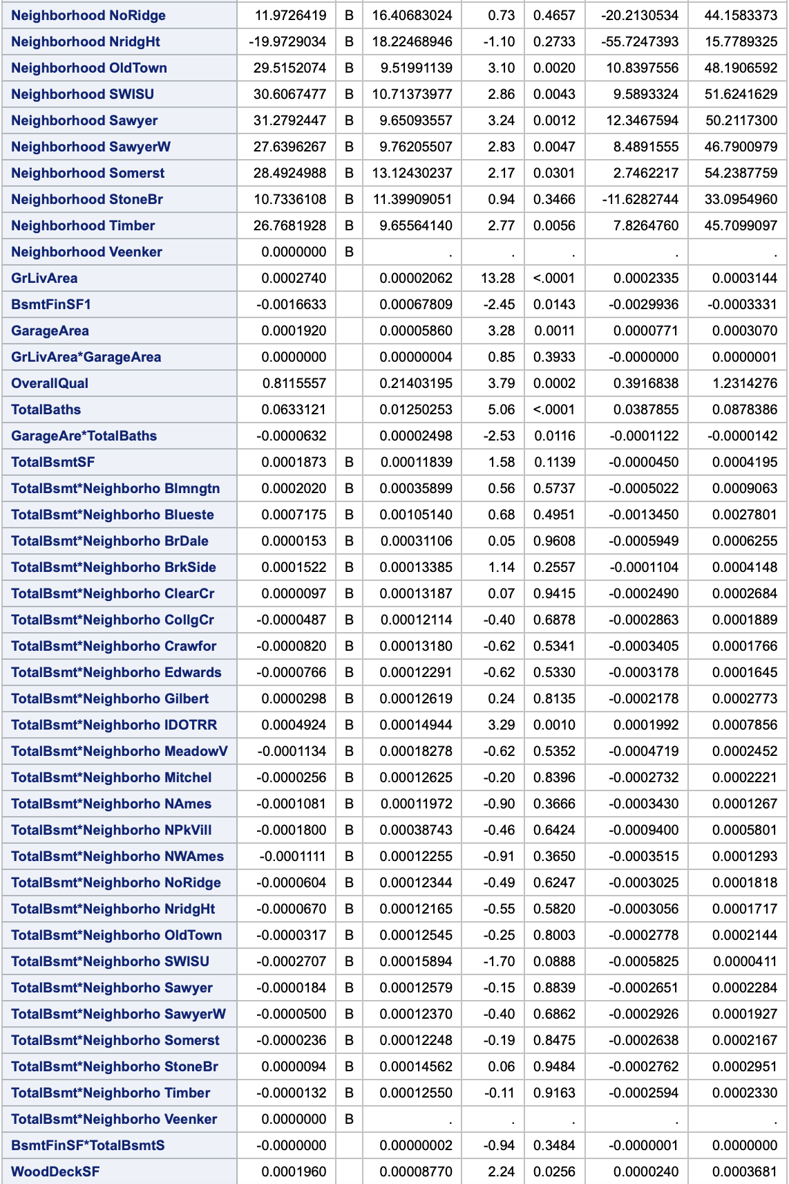

Stepwise selection – Model Estimates

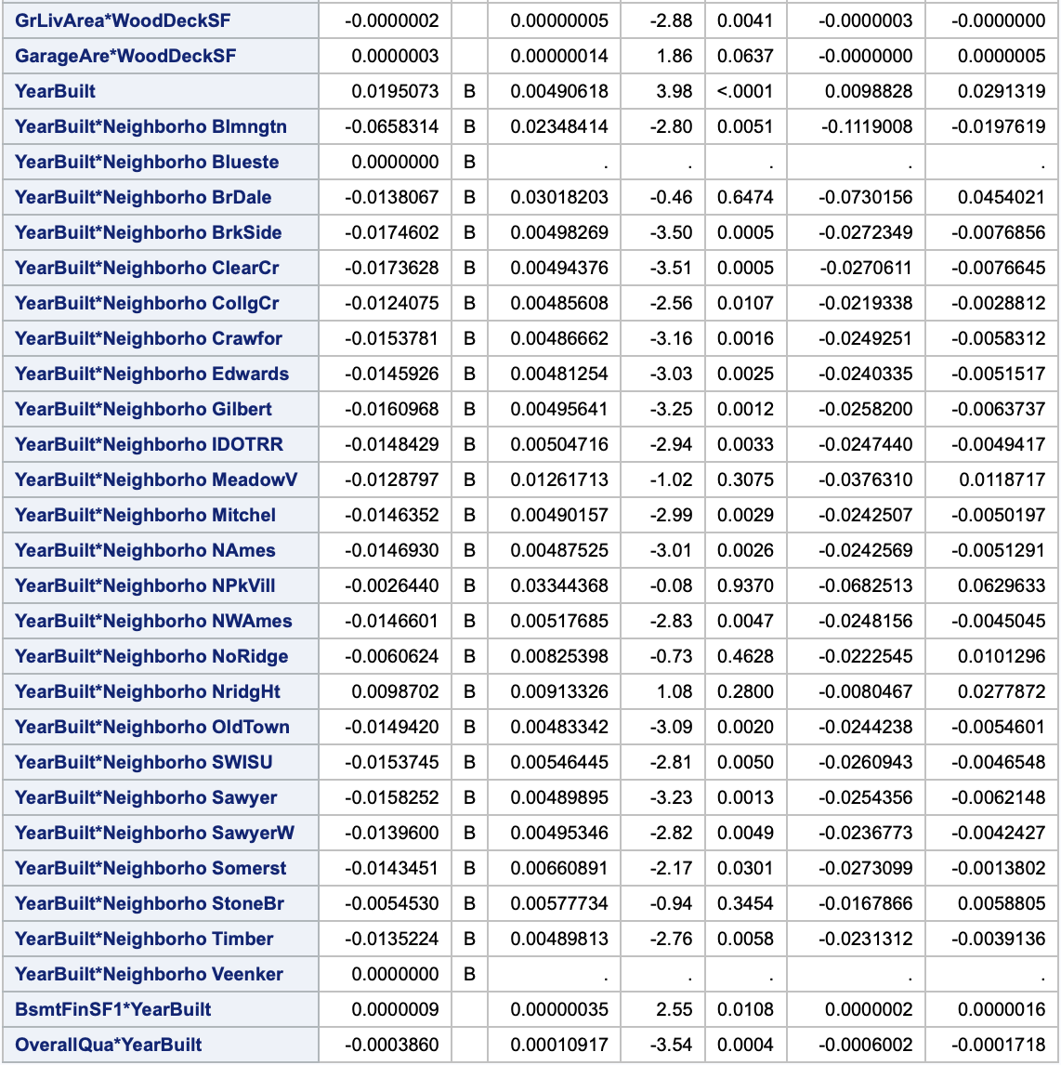

Stepwise selection – Model Estimates

### 

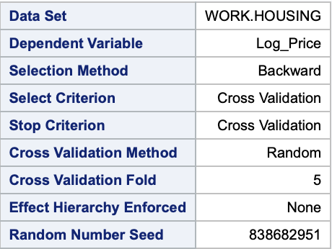

Backward selection – Random Seed Number

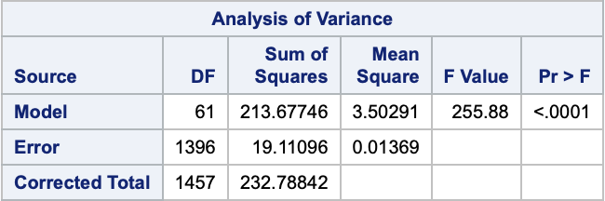

Backward selection – ANOVA Analysis

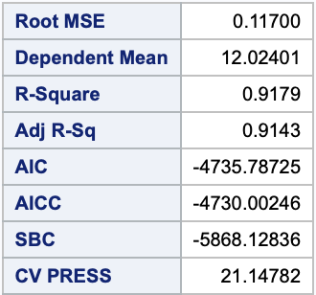

Backward selection – Model Statistics

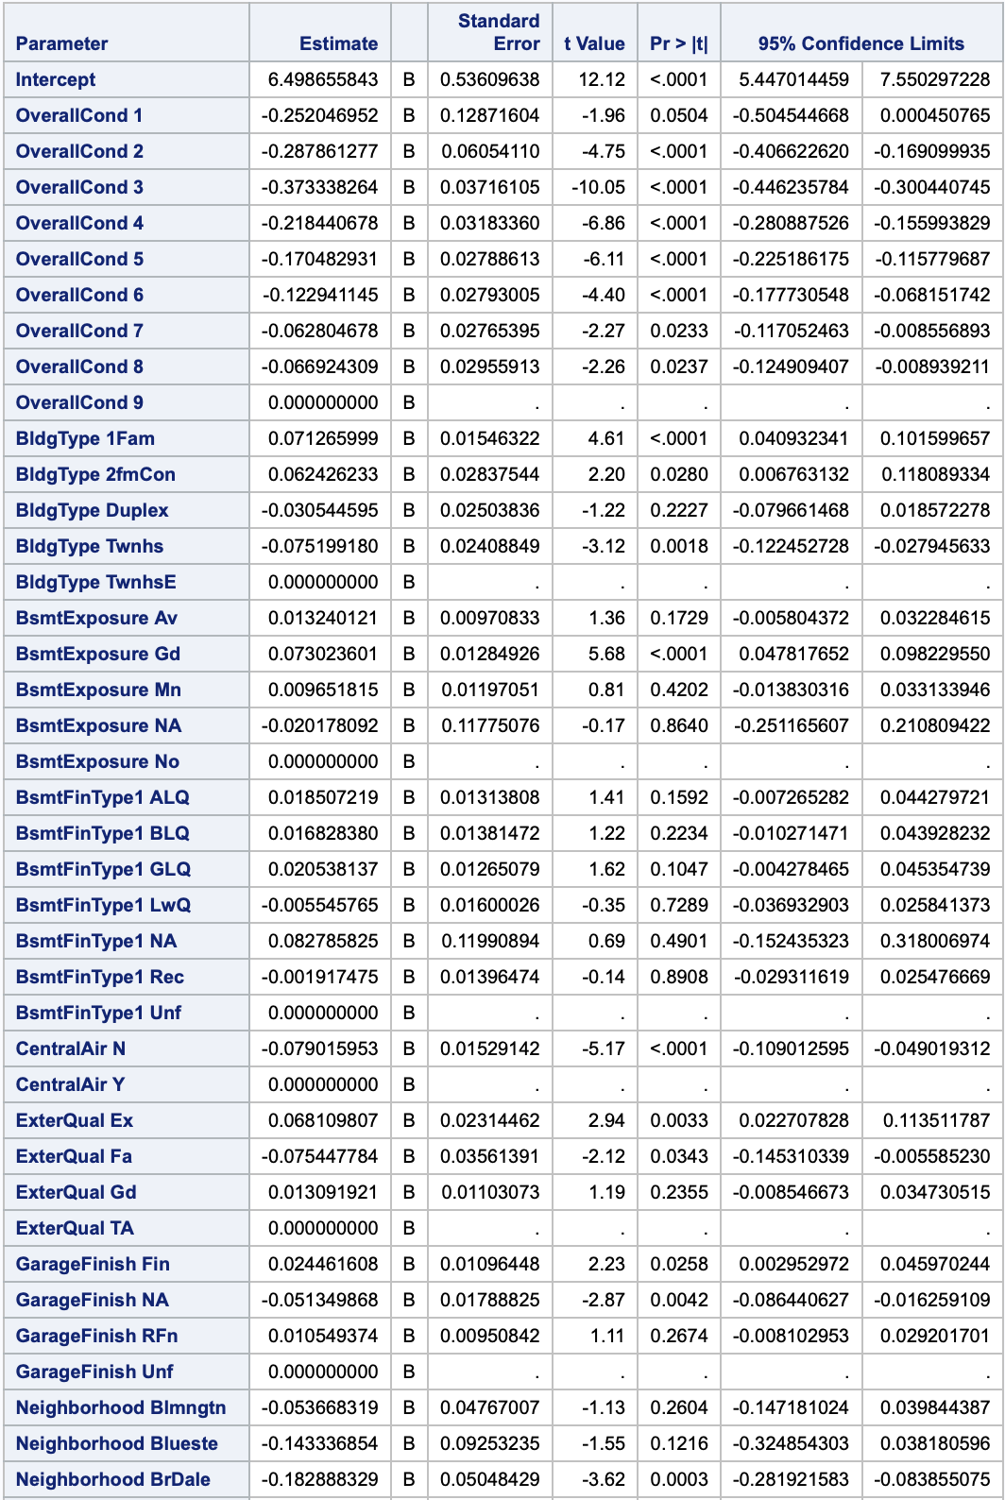

Backward selection – Model Estimates

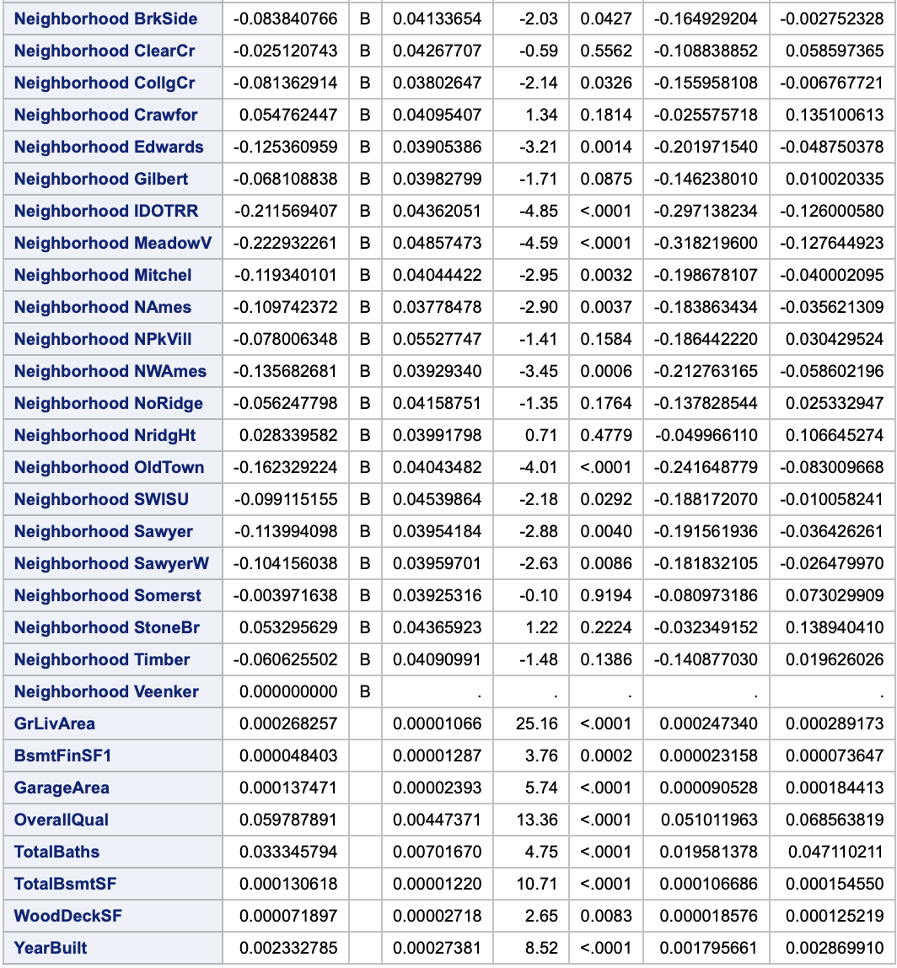

Backward selection – Model Estimates

### 

# Codebook

|  |
| --- |
| /* Question1 */ |
|  | /*Upload data*/  PROC IMPORT DATAFILE="/home/u39793781/sasuser.v94/DS6371 Statistical Foundations/Kaggle/train.csv" |
|  | OUT=WORK.housing |
|  | DBMS=CSV |
|  | REPLACE; |
|  | RUN; |
|  |  |
|  | PROC PRINT DATA=housing; |
|  | RUN; |
|  |  |
|  | /* Remove NAs from Numeric Columns */ |
|  | /* GarageYrBlt, MasVnrArea, and LotFrontage */ |
|  | DATA housing; |
|  | SET housing; |
|  | IF GarageYrBlt = NA THEN GarageYrBlt = ""; |
|  | IF MasVnrArea = NA THEN MasVnrArea = ""; |
|  | IF LotFrontage = NA THEN LotFrontage = ""; |
|  | RUN; |
|  |  |
|  | PROC PRINT DATA=housing; |
|  | RUN; |
|  |  |
|  | /* Rename variables starting with an integer */ |
|  | DATA housing; |
|  | SET housing; |
|  | RENAME "1stFlrSF"n = _1stFlrSF; |
|  | RENAME "2ndFlrSF"n = _2ndFlrSF; |
|  | RENAME "3SsnPorch"n = _3SsnPorch; |
|  | RUN; |
|  |  |
|  | PROC PRINT DATA = housing; |
|  | RUN; |
|  |  |
|  | /*Filter data for Neighborhoods of interest */ |
|  | DATA Cent_21_Ames; |
|  | SET housing; |
|  | WHERE Neighborhood="NAmes" | Neighborhood="Edwards" | Neighborhood="BrkSide"; |
|  | RUN; |
|  |  |
|  | /*Scatterplot Sale Price by Living Area by Group*/ |
|  | SYMBOL1 V='N' C = green I=none; |
|  | SYMBOL2 V='E' C = red I = none; |
|  | SYMBOL3 V='B' C = blue I = none; |
|  | Title 'Sale Price vs. Living Area by Neighborhood'; |
|  | PROC GPLOT data = Cent_21_Ames; |
|  | PLOT SalePrice * GRLivArea = Neighborhood; |
|  | RUN; |
|  |  |
|  | /*Plots Assumptions*/ |
|  | PROC GLM DATA = Cent_21_Ames PLOTS = ALL; |
|  | CLASS Neighborhood; |
|  | MODEL SalePrice = GrLivArea | Neighborhood / SOLUTION CLPARM TOLERANCE; |
|  | RUN; |
|  |  |
|  | /* Dropped Outliers: Data */ |
|  | DATA Cent_21_Ames2; SET Cent_21_Ames; |
|  | IF GrLivArea > 4000 THEN delete; |
|  | RUN; |
|  |  |
|  | PROC PRINT DATA=Cent_21_Ames2; |
|  | RUN; |
|  |  |
|  | /* Dropped Outliers: Assumptions */ |
|  | PROC GLM DATA = Cent_21_Ames2 PLOTS = ALL; |
|  | CLASS Neighborhood; |
|  | MODEL SalePrice = GrLivArea | Neighborhood / SOLUTION CLPARM TOLERANCE; |
|  | RUN; |
|  |  |
|  | /* Log Transformations (After Outlier Drop) */ |
|  | DATA Cent_21_Ames2; |
|  | SET Cent_21_Ames2; |
|  | Log_Price = log(SalePrice); |
|  | RUN; |
|  |  |
|  | /* Log-Linear Assumptions Check */ |
|  | PROC GLM DATA = Cent_21_Ames2 PLOTS = ALL; |
|  | CLASS Neighborhood; |
|  | MODEL Log_Price = GrLivArea | Neighborhood / SOLUTION CLPARM TOLERANCE; |
|  | RUN; |
|  |  |
|  | /* Log-Linear AdjRsq and Int CV PRESS */ |
|  | PROC GLMSELECT DATA=Cent_21_Ames2; |
|  | CLASS Neighborhood; |
|  | MODEL Log_Price = GrLivArea | Neighborhood / SELECTION = Forward (STOP = CV) CVDETAILS = CVPress; |
|  | RUN; |

|  |
| --- |
| /* Question 2 */ |
|  | /* Import Training Data Set*/ |
|  | PROC IMPORT DATAFILE = "/home/u44533688/New Folder/train.csv" |
|  | OUT = WORK.housingtrain |
|  | DBMS = CSV |
|  | REPLACE; |
|  | DATAROW = 2; |
|  | RUN; |
|  | PROC PRINT DATA = housingtrain; |
|  | RUN; |
|  | /* Data manipulation step */ |
|  | DATA housingtrain; |
|  | SET housingtrain; |
|  | /* Combine all bath count data to make more linear */ |
|  | TotalBaths = FullBath + 0.5*HalfBath + BsmtFullBath + 0.5*BsmtHalfBath; |
|  | /* log transform of price */ |
|  | Log_Price = LOG(SalePrice); |
|  | /* Cannot import without SAS reading as character and truncating numbers to w=2. |
|  | Would need much longer data step to fix - cor with other variables so drop */ |
|  | DROP LotFrontage; |
|  | /* No garage - set to year home built */ |
|  | IF GarageYrBlt = "NA" THEN GarageYrBlt = YearBuilt; |
|  | /* Convert NA for veneer to zero */ |
|  | IF MasVnrArea = "NA" THEN MasVnrArea = "0"; |
|  | /* Drop extreme outliers from training set */ |
|  | IF GrLivArea > 4600 THEN DELETE; |
|  | /* If using SAS Studio On Demand, name change is needed. |
|  | Using local/citrix version does this automatically */ |
|  | RENAME "1stFlrSF"n = _1stFlrSF; |
|  | RENAME "2ndFlrSF"n = _2ndFlrSF; |
|  | RENAME "3SsnPorch"n = _3SsnPorch; |
|  | RUN; |
|  | /* Check data manipulation actions */ |
|  | PROC PRINT DATA = housingtrain; |
|  | RUN; |
|  | /* Import Test Data Set*/ |
|  | PROC IMPORT DATAFILE= "/home/u44533688/New Folder/test.csv" |
|  | OUT = WORK.housingtest |
|  | DBMS = CSV |
|  | REPLACE; |
|  | DATAROW = 2; |
|  | RUN; |
|  | PROC PRINT DATA = housingtest; |
|  | RUN; |
|  | /* Data manipulation step */ |
|  | DATA housingtest; |
|  | SET housingtest; |
|  | /* Combine all bath count data to make more linear */ |
|  | TotalBaths = FullBath + 0.5*HalfBath + BsmtFullBath + 0.5*BsmtHalfBath; |
|  | /* log transform of price */ |
|  | Log_Price = LOG(SalePrice); |
|  | /* Cannot import without SAS reading as character and truncating numbers to w=2. |
|  | Would need much longer data step to fix - cor with other variables so drop */ |
|  | DROP LotFrontage; |
|  | /* No garage - set to year home built */ |
|  | IF GarageYrBlt = "NA" THEN GarageYrBlt = YearBuilt; |
|  | /* Convert NA for veneer to zero */ |
|  | IF MasVnrArea = "NA" THEN MasVnrArea = "0"; |
|  | /* If using SAS Studio On Demand, name change is needed. |
|  | Using local/citrix version does this automatically */ |
|  | RENAME "1stFlrSF"n = _1stFlrSF; |
|  | RENAME "2ndFlrSF"n = _2ndFlrSF; |
|  | RENAME "3SsnPorch"n = _3SsnPorch; |
|  | RUN; |
|  | PROC PRINT DATA = housingtest; |
|  | RUN; |
|  | /*Combine training and test data sets*/ |
|  | DATA housing2; |
|  | SET housingtrain housingtest; |
|  | RUN; |
|  | PROC PRINT DATA = housing2; |
|  | RUN; |
|  |  |
|  |  |
|  | /* All models use "CV" options to minimize press (overfitting) */ |
|  | /* Backward Selection Method - no interactions */ |
|  | PROC GLMSELECT DATA = housing2 PLOTS = all; |
|  | CLASS OverallCond BldgType BsmtExposure BsmtFinType1 CentralAir ExterQual GarageFinish Neighborhood; |
|  | MODEL Log_Price = OverallCond BldgType BsmtExposure BsmtFinType1 CentralAir ExterQual GarageFinish Neighborhood GrLivArea BsmtFinSF1 GarageArea MasVnrArea OverallQual TotalBaths TotalBsmtSF WoodDeckSF YearBuilt _1stFlrSF |
|  | / SELECTION = backward (SELECT = cv STOP = cv) SHOWPVALUES CVDETAILS = cvpress; |
|  | OUTPUT OUT = bresults P = predict; |
|  | RUN; |
|  |  |
|  | /*Confidence Intervals for backward selection model*/ |
|  | PROC GLM DATA=housing2; |
|  | Class OverallCond BldgType BsmtExposure BsmtFinType1 CentralAir ExterQual GarageFinish Neighborhood; |
|  | Model Log_Price = OverallCond BldgType BsmtExposure BsmtFinType1 CentralAir ExterQual GarageFinish Neighborhood GrLivArea BsmtFinSF1 GarageArea OverallQual TotalBaths TotalBsmtSF WoodDeckSF YearBuilt / solution clparm; |
|  | RUN; |
|  |  |
|  | /* Backward Selection Method - no interactions CSV for Kaggle Submission*/ |
|  | DATA bresults2; |
|  | SET bresults; |
|  | unlogpredict = EXP(predict); |
|  | IF unlogpredict > 0 THEN SalePrice = unlogpredict; |
|  | /* Use 100 * Sq footage to estimate any values that are less than 0 and create kaggle submission set */ |
|  | IF unlogpredict < 0 THEN SalePrice = 100*GrLivArea; |
|  | KEEP id SalePrice; |
|  | WHERE id > 1460; |
|  | run; |
|  | PROC EXPORT DATA = bresults2 DBMS = csv |
|  | FILE = "/home/u44533688/New Folder/bresults2.csv" |
|  | REPLACE; |
|  | run; |
|  | /* Forward Selection Method - no interactions */ |
|  | PROC GLMSELECT DATA = housing2 PLOTS = all; |
|  | CLASS OverallCond BldgType BsmtExposure BsmtFinType1 CentralAir ExterQual GarageFinish Neighborhood; |
|  | MODEL Log_Price = OverallCond BldgType BsmtExposure BsmtFinType1 CentralAir ExterQual GarageFinish Neighborhood GrLivArea BsmtFinSF1 GarageArea MasVnrArea OverallQual TotalBaths TotalBsmtSF WoodDeckSF YearBuilt _1stFlrSF |
|  | / SELECTION = forward (SELECT = cv STOP = cv) SHOWPVALUES CVDETAILS = cvpress; |
|  | OUTPUT OUT = fresults P = predict; |
|  | RUN; |
|  |  |
|  | /*Confidence Intervals for forward selection model*/ |
|  | PROC GLM DATA=housing2; |
|  | Class OverallCond BldgType BsmtExposure CentralAir ExterQual GarageFinish Neighborhood; |
|  | Model Log_Price = OverallCond BldgType BsmtExposure CentralAir ExterQual GarageFinish Neighborhood GrLivArea BsmtFinSF1 GarageArea OverallQual TotalBaths TotalBsmtSF WoodDeckSF YearBuilt / solution clparm; |
|  | RUN; |
|  |  |
|  | /* Forward Selection Method no Interactions for Kaggle Submission */ |
|  | DATA fresults2; |
|  | SET fresults; |
|  | unlogpredict = EXP(predict); |
|  | IF unlogpredict > 0 THEN SalePrice = unlogpredict; |
|  | /* Use 100 * Sq footage to estimate any values that are less than 0 and create kaggle submission set */ |
|  | IF unlogpredict < 0 THEN SalePrice = 100*GrLivArea; |
|  | KEEP id SalePrice; |
|  | WHERE id > 1460; |
|  | RUN; |
|  | PROC EXPORT DATA = fresults2 DBMS = csv |
|  | FILE = "/home/u44533688/New Folder/fresults2.csv" |
|  | REPLACE; |
|  | RUN; |
|  | /* Stepwise Selection Method w/ Neighborhood & Numeric Interactions */ |
|  | PROC GLMSELECT DATA = housing2 PLOTS = all; |
|  | CLASS OverallCond BldgType BsmtExposure BsmtFinType1 CentralAir ExterQual GarageFinish Neighborhood; |
|  | MODEL Log_Price = OverallCond BldgType BsmtExposure BsmtFinType1 CentralAir ExterQual GarageFinish Neighborhood | GrLivArea | BsmtFinSF1 | GarageArea | MasVnrArea | OverallQual | TotalBaths | TotalBsmtSF | WoodDeckSF | YearBuilt | _1stFlrSF @2 |
|  | / SELECTION = stepwise (SELECT = cv STOP = cv) SHOWPVALUES HIER=SINGLE CVDETAILS = cvpress; |
|  | OUTPUT OUT = sresults P = predict; |
|  | RUN; |
|  |  |
|  | /*Confidence Intervals for stepwise model*/ |
|  | PROC GLM DATA=housing2; |
|  | Class OverallCond BldgType BsmtExposure CentralAir ExterQual GarageFinish Neighborhood; |
|  | Model Log_Price = OverallCond BldgType BsmtExposure CentralAir ExterQual GarageFinish Neighborhood GrLivArea BsmtFinSF1 GarageArea GrLivArea*GarageArea OverallQual TotalBaths GarageArea*TotalBaths TotalBsmtSF TotalBsmtSF*Neighborhood BsmtFinSF1*TotalBsmtSF WoodDeckSF GrLivArea*WoodDeckSF GarageArea*WoodDeckSF YearBuilt YearBuilt*Neighborhood BsmtFinSF1*YearBuilt OverallQual*YearBuilt / solution clparm; |
|  | RUN; |
|  |  |
|  | /* Stepwise Selection Method w/ Neighborhood & Numeric Interactions for Kaggle Submission */ |
|  | DATA sresults2; |
|  | SET sresults; |
|  | unlogpredict = EXP(predict); |
|  | IF unlogpredict > 0 then SalePrice = unlogpredict; |
|  | /* Use 100 * Sq footage to estimate any values that are less than 0 and create kaggle submission set */ |
|  | IF unlogpredict < 0 then SalePrice = 100*GrLivArea; |
|  | KEEP id SalePrice; |
|  | WHERE id > 1460; |
|  | RUN; |
|  | proc export DATA = sresults2 DBMS = csv |
|  | FILE = "/home/u44533688/New Folder/sresults2.csv" |
|  | REPLACE; |
|  | RUN; |